Solution Architecture
Project Design Phase | Logical architecture and operating boundaries
Project | Automated Network Request Management | Date | 20 October 2026
Owner / demonstrator | PILLEM RAHUL | SkillWallet ID | SWUID2026232277
Platform | ServiceNow PDI | Repository | https://github.com/rahulp06/Automated_Network_Request_Management_in_ServiceNow

Phase: 3. Project Design Phase

Logical architecture
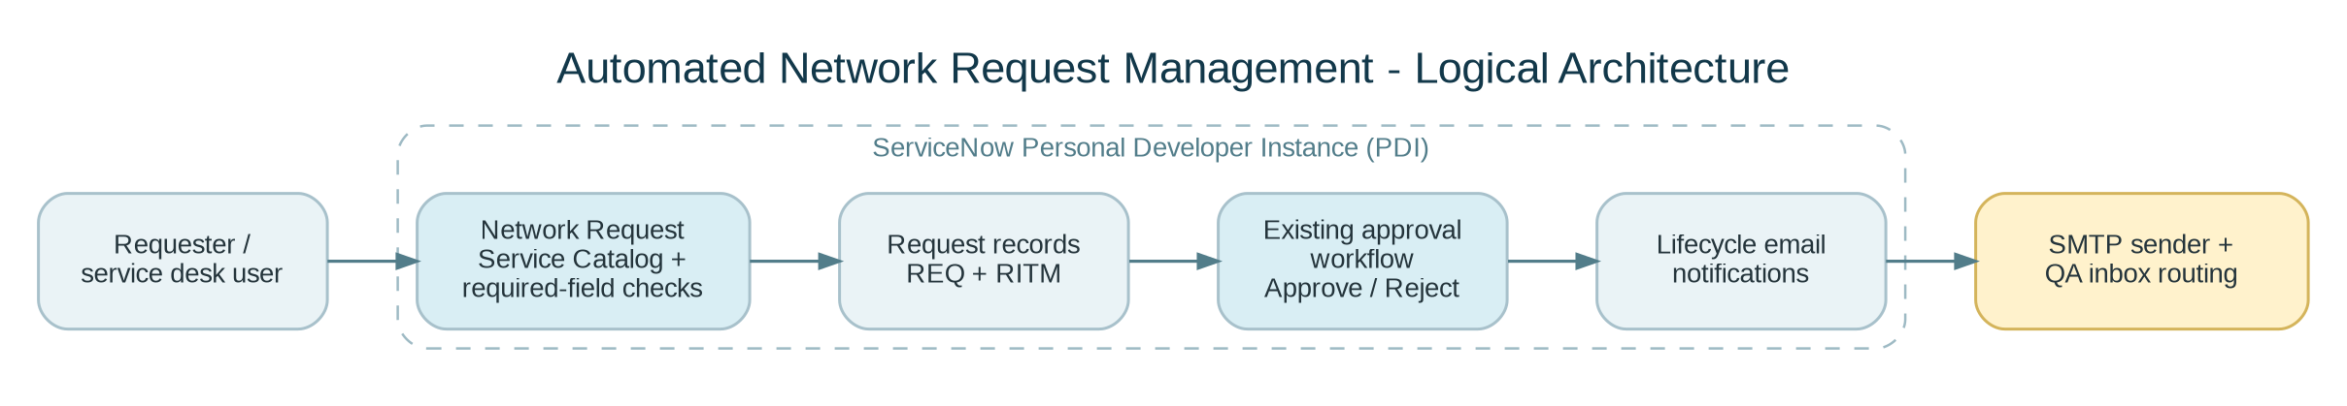
Figure 1. Logical architecture of the Network Request solution.

Component responsibilities
Component | Responsibility | Control / note
Network Request catalog item | Captures requester variables. | Mandatory markers and incomplete-order validation verified.
REQ / RITM records | Stores parent request and requested item. | Parent/child linkage verified for REQ0010004 / RITM0010005.
Existing approval flow | Routes approval/rejection decision. | Both paths tester-confirmed; internal flow nodes not independently audited.
Notification records | Builds lifecycle email content. | Generated email subject/body inspected.
SMTP Sender | Transmits outbound notifications. | Custom Gmail SMTP account activated after successful test connection.
QA inbox routing | Redirects all outbound mail for non-production QA. | Global routing; retain until remaining queued messages are inspected.
Email Diagnostics | Shows sender state, queue and last-sent time. | Sender Running and a last-sent timestamp observed; five messages remained queued.

Security and resilience considerations
- Keep SMTP App Password out of documentation, repository, video and screenshots.
- Keep `glide.email.test.user` configured during QA; it applies to all outbound messages in the instance.
- Do not manually delete or alter queued mail records without inspecting state/reason.
- Email receiving was non-operational in diagnostics; inbound processing is not required by the verified outbound flow.
- Production readiness requires authorized credential management, ACL review, audit trace review and performance/security review.

